**Group Project 11 – User Interface Use Case Document**

Author: Bhagya Wanni Arachchige (bhw)

Version: 1.0

Status: For review

Config Ref: UISpecGroup11

Date: 28February 2022

Department of Computer Science

Aberystwyth University

Aberystwyth

Ceredigion

SY23 3DB

Copyright © Aberystwyth University 2020

**Contents**

1 – Introduction 3

1.1 – Purpose of this document 3

1.2 – Scope 3

1.3 – Objectives 3

2 – Use Case document 3

2.1 – Typical users 3

2.2 – UML diagram for use cases 4

2.3 – Use cases for players 4

3 – Errors 7

4 – References 9

## 1 – Introduction

### – Purpose of this document

The purpose of this document is to model and describe the general behaviour of the system listing any interactions between the user and the system’s functionality.

### 1.2 – Scope

This document identifies the typical users of the system and any tasks they might carry out whilst the system is running also considering any errors that may occur as these tasks are carried out.

### 1.3 – Objectives

The objectives of this document are:

* List all the users that can interact with the system
* Describe the types of interactions that must be supported
* Identify any errors that may arise

## 2 – Use Case document

### 2.1 – Typical users

* Players
  + Example: 4 users named Bob, John, Jack, and Brian start the game and enter their names. Each player is given a boat and the game then randomly allocates five crew cards and a home island to each player. The players are now free to play the game by moving their ship, attacking other players, collecting treasure, building a bigger crew, and eventually ending the game by accumulating 20 points worth of treasure at their home port.
  + Types of players: Gamers, board game enthusiasts and families

### 2.2 – UML diagram for use cases

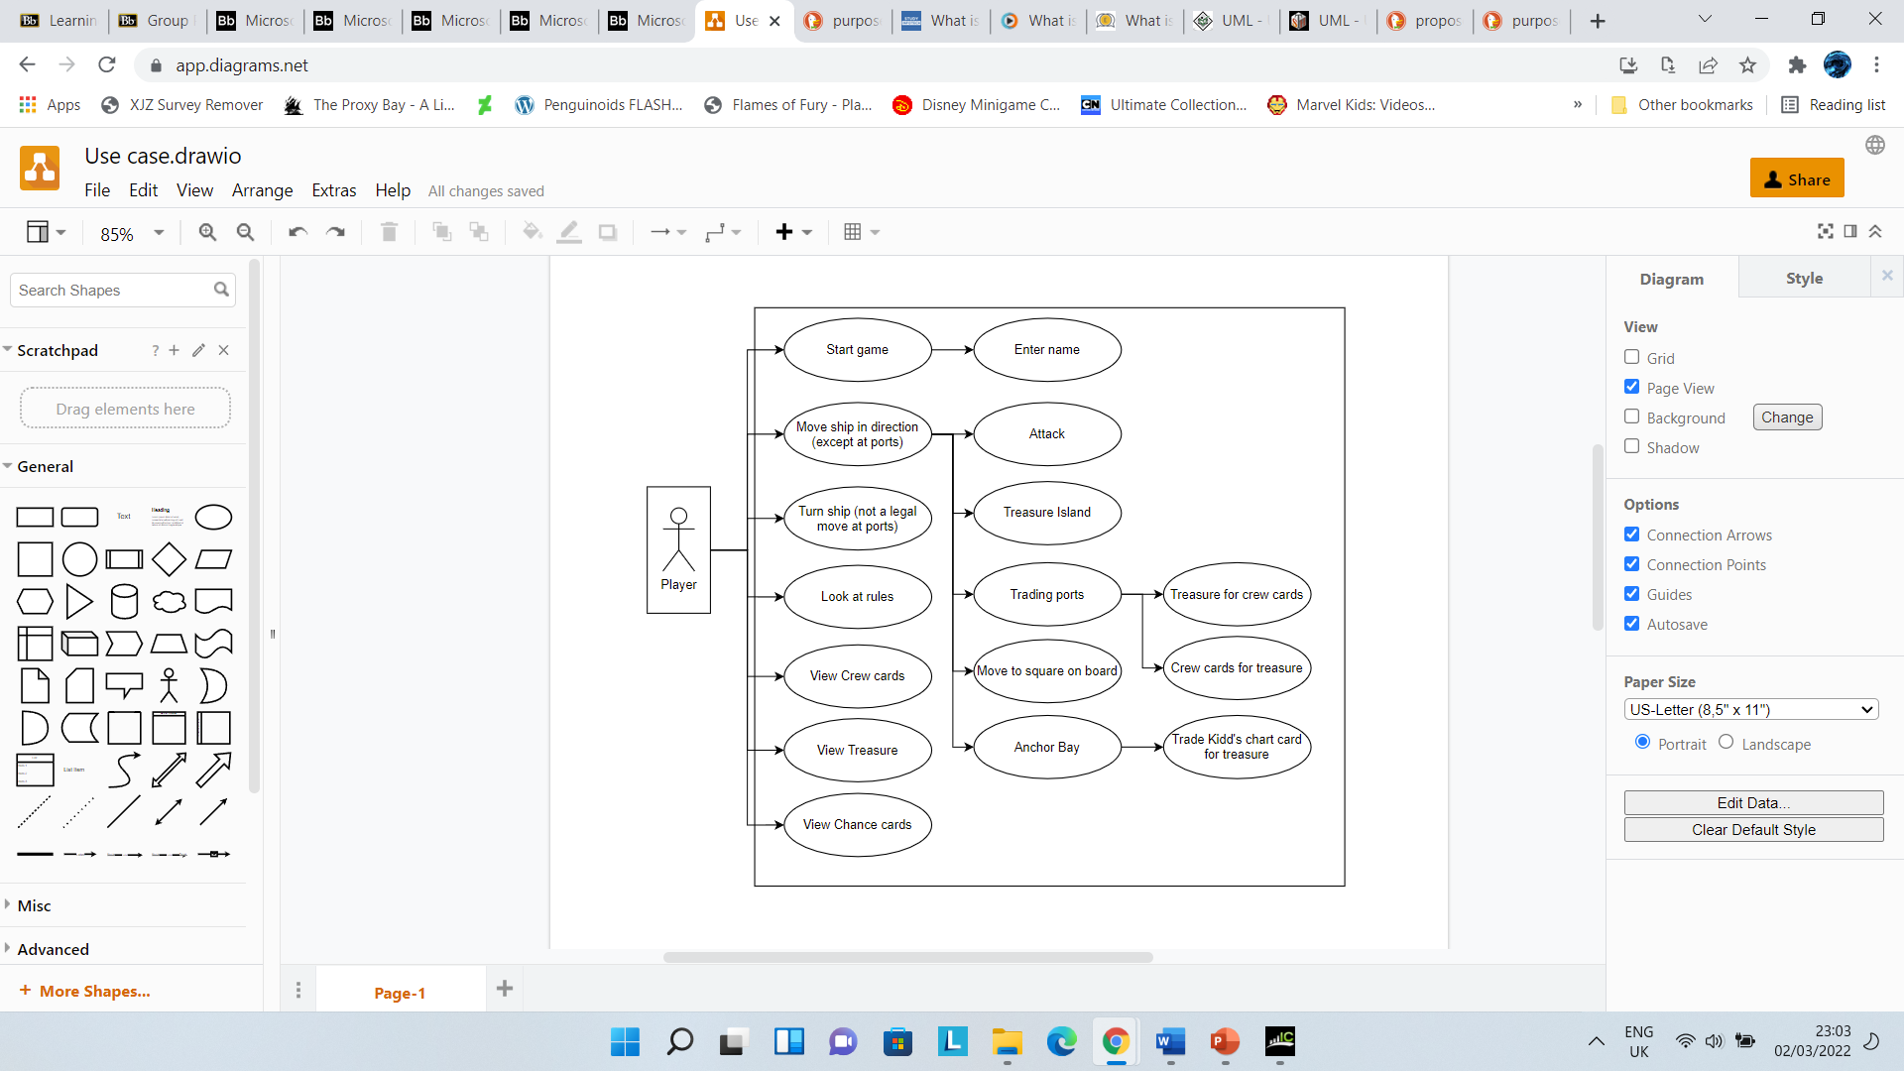

### 2.3 – Use cases for players

1. Start the game and enter a username
2. Look at rules
3. Move ship
   1. Attack ship
   2. Treasure Island
   3. Flat Island
   4. Trading port
   5. Anchor Bay
4. Turn ship (Not a legal move at trading ports)
5. View crew cards
6. View treasure
7. View Chance cards

**Use Case 1.1:**

The players are presented with a starting screen where each player can enter a username. The players must then click on the ready up button to ensure that all players are ready to proceed to the game. When all the players are ready the continue button can be pressed to load the board game screen.

Each player is then randomly assigned to one of the 4 ports of London, Genoa, Marseilles, and Cadiz as a home port and 5 randomly picked crew cards are added to their deck. The board is then created, crew cards are placed on Pirate Island and treasure items are assigned to the appropriate locations e.g., ports and Treasure Island (*refer to use case 1.3.2*). After the creation of the board Player 1’s turn commences.

Use case UML diagram


**Use Case 1.2:**

If the players wish to familiarise themselves with the rule of the game, they can do so by clicking the rules button located on the board game screen. Once pressed the rules button loads a pop-up screen listing all the rules of the board game.

**Use Case 1.3:**

Once it is their turn, a player may choose to move their ship. A player can move their ship, in the direction it is facing, several squares up to the total of their crew cards or one square if no crew cards are held. A ship is moved by selecting a valid square on the board and pressing the “move” button but if a square is not selected initiate turn sequence (*refer to use case 1.4 for details on how the ship is turned*).

If the player’s ship is moved to the square occupied by another player, they must initiate an attack (*refer to use case 1.3.1 for details on attacking).* If the ship is moved to a square adjacent to either Treasure or Flat Island the menu for the Island is displayed (*refer to use cases 1.3.2 and 1.3.3 for the detailed description on Treasure Island and Flat Island respectively*). After any move not involving a player is required to choose the direction they are facing (*refer to use case 1.4*).

If the player returns to their homeport and manages to store 3 identical treasures, those treasures are placed in the player’s “safe zone” and can no longer be traded.

**Use Case 1.3.1:**

When two players occupy the same square an attack commences, two pop-up screens depicting the players’ combat scores are shown, the player with the higher combat value wins.

The loser of the exchange is then required to move their ship in any direction which is followed by a change in direction (*refer to use case 1.4*).

**Use Case 1.3.2:**

Treasure island initially holds all the treasure and chance cards on the board. When a player reaches treasure island, they are given the chance card at the top of the deck. The chance card is shown via a pop-up screen that can be manually closed by the player. If the card that is picked needs to be held then that card is added to the player’s chance card store which can be viewed by clicking on the “Chance cards” tab (*refer to use case 1.7*) otherwise the effects of the cards are carried automatically out by the game.

**Use Case 1.3.3:**

When a player reaches Flat Island, they are awarded any treasure that is present as long as the player has space on their ship. If the player can only hold 1 treasure item, they are awarded the highest valued treasure on Flat Island. The awarded treasure is shown via a pop-up screen that can be manually closed by the player. Treasure is added to the player’s ship treasure store (*refer to use case 1.6*). Any crew cards on Flat Island are automatically added to the player’s deck (*refer to use case 1.5*).

**Use Case 1.3.4:**

If a player ship arrives at a port, they are presented with they are shown the trading menu, a pop-up screen consisting of the treasure and cards at the port and the treasure and cards that the player holds. At this point, a player may also use any chance cards they have. If the valid criterion for a trade is met then an exchange occurs, if the port is home to another player, then any crew cards exchanged are automatically added to that player’s deck. The game also updates the values of cards and treasures at the port accordingly.

**Use Case 1.3.5:**

A Player may choose to sail their boat to the Anchor Bay location. If chance cards 25 or 26 (Kidd’s chart) is in their possession, then the game proceeds to show them the trade menu (*refer to use case 1.3.4 for details on the menu*). This allows the player to trade the chance card for treasure items, worth up to a value of 7, found on Treasure Island (*refer to use case 1.3.2*).

**Use Case 1.4:**

A player’s direction is shown through a graphical compass (located on the top right of the screen) with an arrow indicating the direction the player’s ship is facing. To turn their ship the player must click on the “turn ship” button which after being pressed allows the player to interact with the compass, this is highlighted and enlarged. The player can select the directional buttons which decide the direction their ship will face. This choice is confirmed by clicking a “confirm” button. This option is not valid at ports and players can move in any direction.

**Use Case 1.5:**

To view the crew cards currently held by the player, the “Crew card” tab should be pressed. When pressed a pop-up window listing the crew cards of the current player is shown, this can be manually closed by the player. Crew cards are stackable and multiple of the same crew card is shown using a multiplier e.g., for 2 of the same cards show x2.

**Use Case 1.6:**

To view the treasure currently on the player’s boat, the “Treasure” tab should be pressed. When pressed a pop-up window listing the treasure cards of the current player is shown, this can be manually closed by the player. Treasure items are stackable and multiple treasure items are shown using a multiplier e.g., for 2 pieces of gold show x2.

**Use Case 1.7:**

To view the chance cards currently held by the player, the “Chance card” tab should be pressed. When pressed a pop-up window listing the chance cards of the current player is shown, this can be manually closed by the player. Any chance cards used are returned to the bottom of the deck found of Treasure Island (*refer to use case 1.3.2*).

## 3 – Errors

**Use Case 1.1:**

* Players should be allowed to choose their usernames; a character limit should be placed to ensure that the name isn’t too long.
* Names entered at this stage should be transferred to the main screen that the game is played on.
* Names should be correctly assigned to the player that entered them e.g., Player 1 should not Player 2’s name.
* 4 players are required to play the game.
* Cards and treasures should be allocated to the correct locations. Chance cards should not be on Pirate Island and vice versa.
* Example of incorrect inputs:
  + “” – No input/blank
  + “99999999999999999999999999999999” – Names with more than 20 characters

**Use Case 1.2:**

* Rules should be accurate.
* Rules button should display the rules pop-up screen.
* Make sure that a pop-up appears when the button is pressed.

**Use Case 1.3:**

* Ship should only be able to move in the direction it is facing unless at a port. A ship should not be able to move to the west if it is facing north.
* Ships can only move within the indicated legal squares. A ship should not be able to move 10 squares if the maximum legal square they can move is 9.

**Use Case 1.3.1:**

* For an attack to occur two ships must be on the same square. Ships on different squares should not be able to battle.
* The winner should be the ship with eh higher combat score. A ship with a combat score of 9 should not lose against one with a combat score of 6.
* The loser must make a move after the attack. Two ships should not be on the same square after any attack.

**Use Case 1.3.2:**

* Chances cards should be randomised.
* Chance cards returned to the deck should be placed at the bottom.
* Players should only be able to interact with Treasure Island if their ship is adjacent to it.

**Use Case 1.3.3:**

* H
* Players should only be able to interact with Flat Island if their ship is adjacent to it.

**Use Case 1.3.4:**

**Use Case 1.3.5:**

**Use Case 1.4:**

**Use Case 1.5:**

**Use Case 1.6:**

**Use Case 1.7:**

## 4 – References

Document History

|  |  |  |  |  |
| --- | --- | --- | --- | --- |
| *Version* | *Issue No.* | *Date* | *Changes made to document* | *Changed by* |
| 1.0 | N/A | 14/02/2022 | New document | bhw |